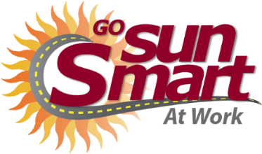
Mini Message Toolkit
Sample posts to share on social media, on electronic bulletin boards, and in emails.
Use these sample posts for your organization’s communication needs. They are intended to raise awareness through social media and other brief communications about melanoma, skin cancer prevention, and early detection. Feel free to use these posts during Skin Cancer Awareness Month for May and/or throughout the year.
Popular hashtags to use: #skincancer #prevention #sunsafety #skincancerawareness #skincancerawarenessmonth
Post | Image or Graphic
Ultraviolet radiation (UV) causes about 9 out of every 10 skin cancers. Protect yourself from damaging UV rays by covering up, seeking shade, using sunscreen, and limiting time outdoors at midday to keep your skin healthy. For more #sunsafety tips visit: https://bit.ly/2x5Ugi2 | 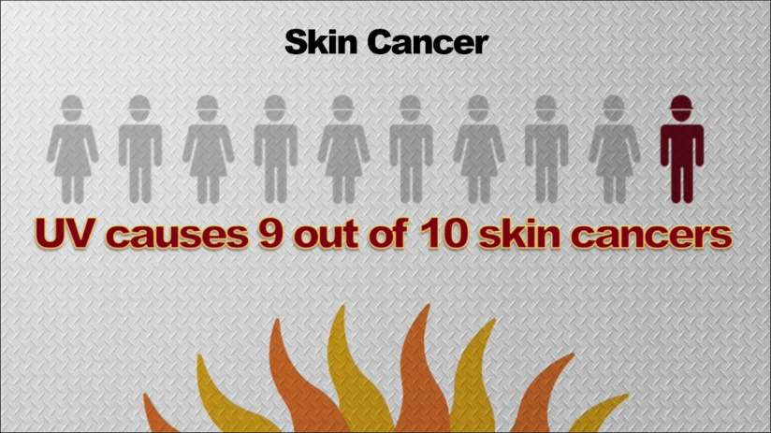
Using sunscreen is a good way to limit your UV exposure while working outside. Keep in mind that sunscreen works best when it’s used correctly – that means use enough and reapply! #skincancer #prevention #sunsafety | 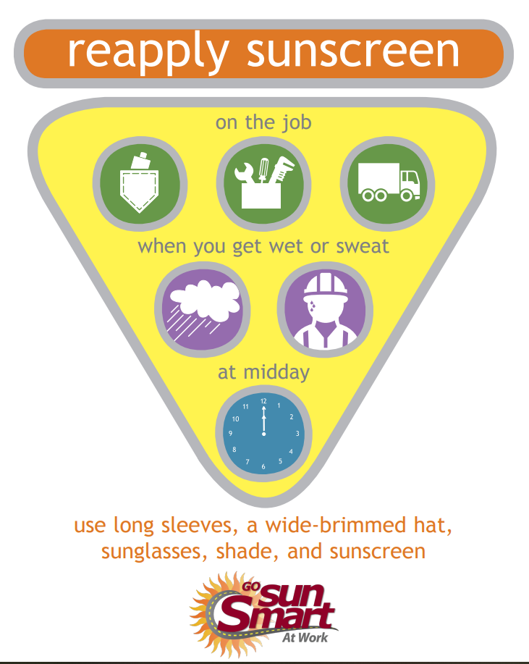
Skin cancer lets you know it’s there. Look for changes in your moles and skin. If you see something new or different talk to your healthcare provider. For more info on what to look for, visit: https://bit.ly/1OkOZCf #skincancerawareness #prevention #detection | 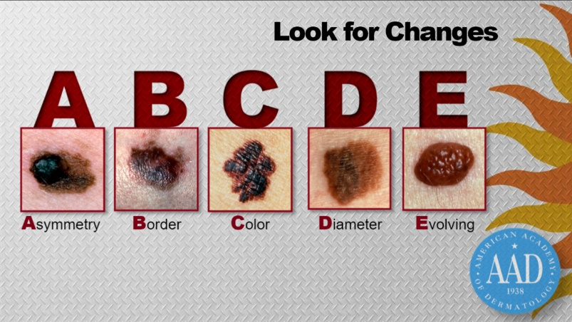

Post | Image or Graphic
Clothing is your best defense against harmful UV while at work. Consider keeping an extra long- sleeved t-shirt in your vehicle to protect your arms from the sun, especially when driving with the window down. #sunsafety #skincancer #prevention | 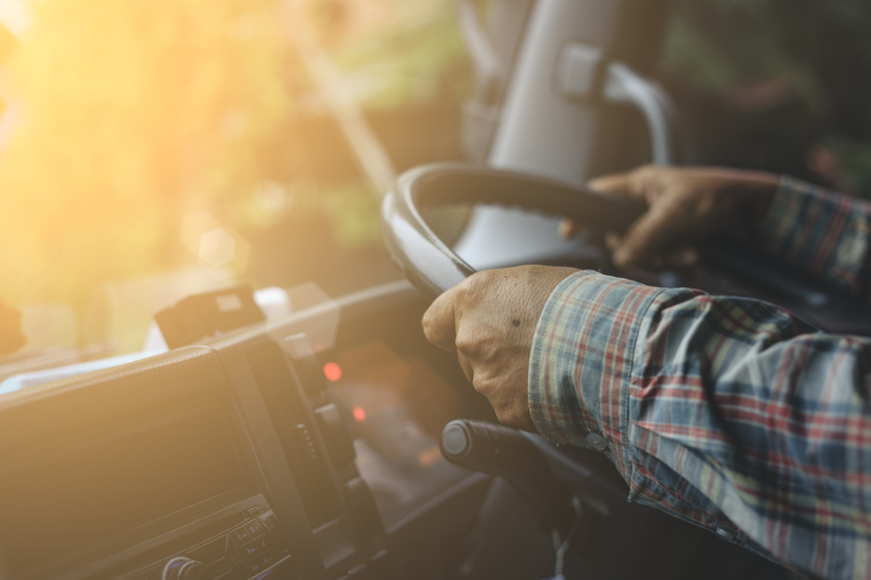
UV is not high all the time, so it’s a good idea to check the UV Index every day to know when to take sun safety precautions. Peak UV hours are usually from 10 am to 4 pm everyday - that’s when sun protection is most needed. ​Check today's UV here: www.epa.gov/sunsafety | 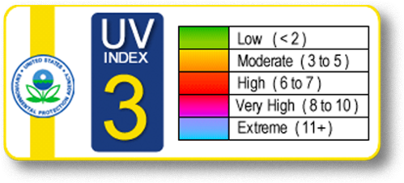
It’s true, UV is lower on rainy days, but you can still get a sunburn on a cloudy day. Clouds screen only about 20-40 percent of UV. Even on cool summer days, UV can still be high and cause damage to your skin if not protected. #skincancer #prevention #sunsafety | 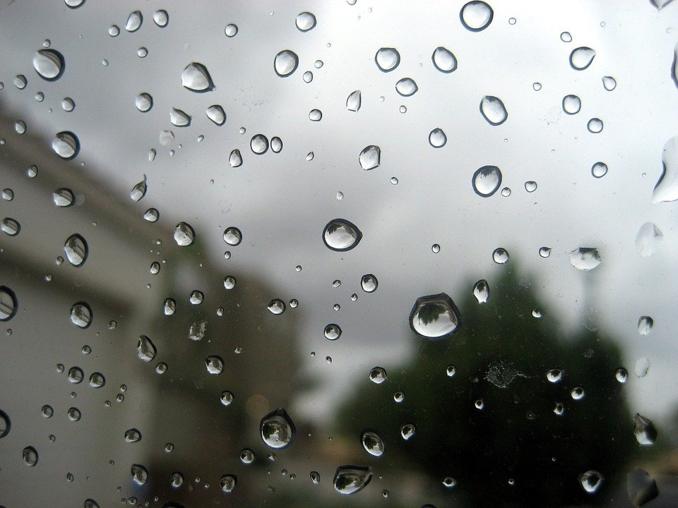

Post | Image or Graphic
Protect your skin from harmful UV when it’s highest at midday by taking your lunch break indoors, in a vehicle, or in the shade whenever possible. #prevention #skincancerawareness | 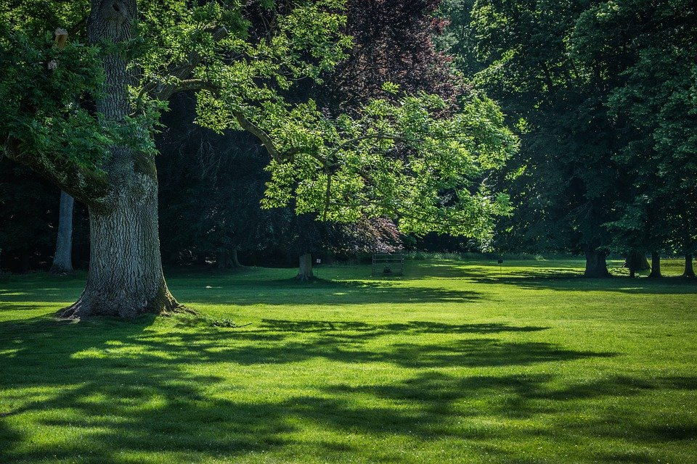
SPF stands for sun protection factor and is a measure of UVB protection. Always use sunscreen with an SPF of 30 or higher when working outdoors. A higher SPF sunscreen means stronger and longer protection. #sunscreen #skincancer | 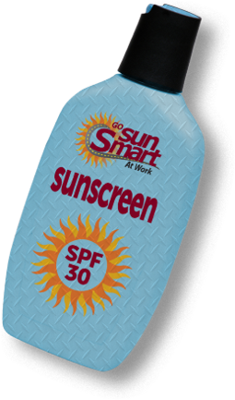
Although auto glass does not block all UV rays, it’s important to note that riding in a vehicle with the window down increases your UV dose 5x more than a closed window. Roll those windows up! #sunsafety #skincancerprevention | 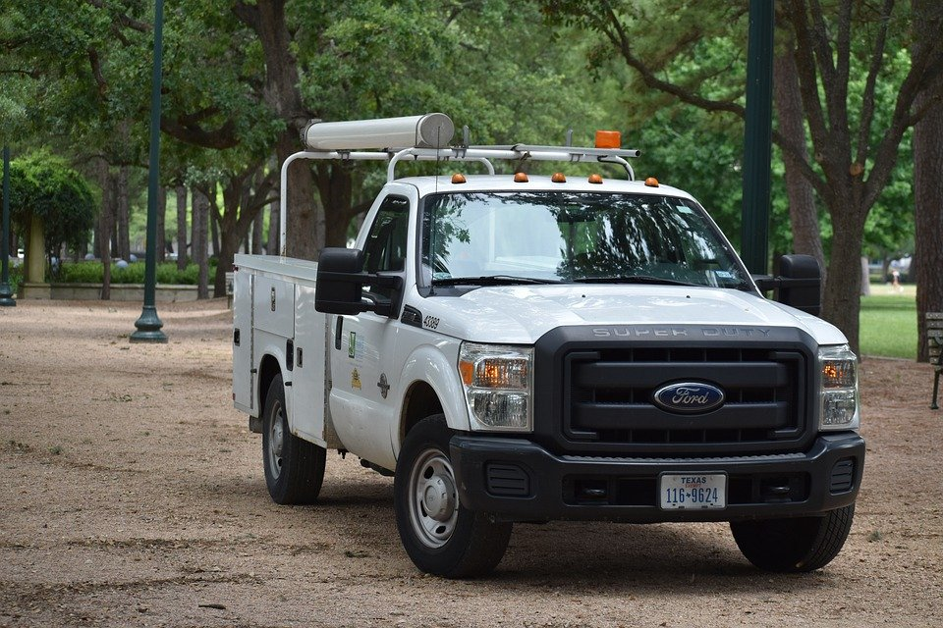

Post | Image or Graphic
Did you know UV is a class 1 carcinogen? It’s in the same category as asbestos, vinyl chloride, radon, and benzene. Protect yourself from UV by practicing #sunsafety on the job. #skincancerawareness #prevention | 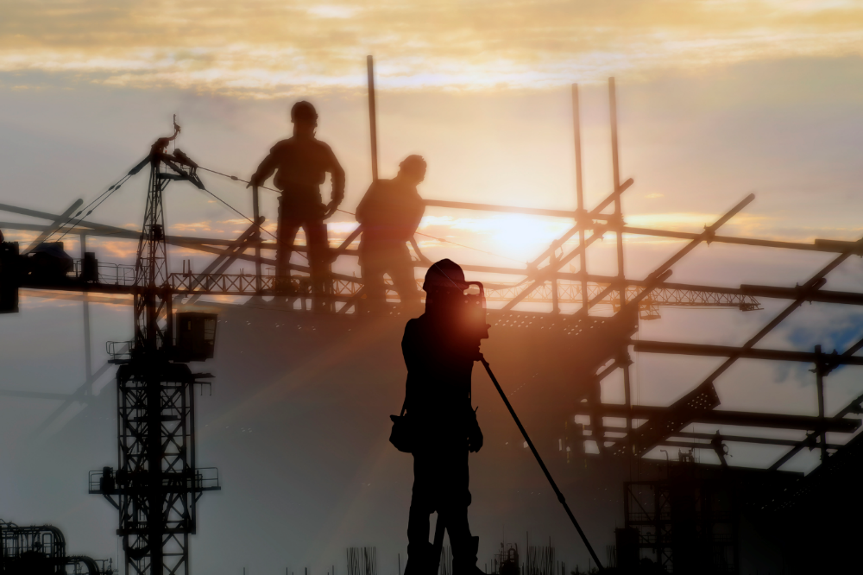
Clothing is the best sunscreen! The more skin it covers, the better. Wear a long-sleeved shirt to protect your arms from the sun. Choose sweat-wicking fabrics for comfort. #sunsafety #skincancer #prevention | 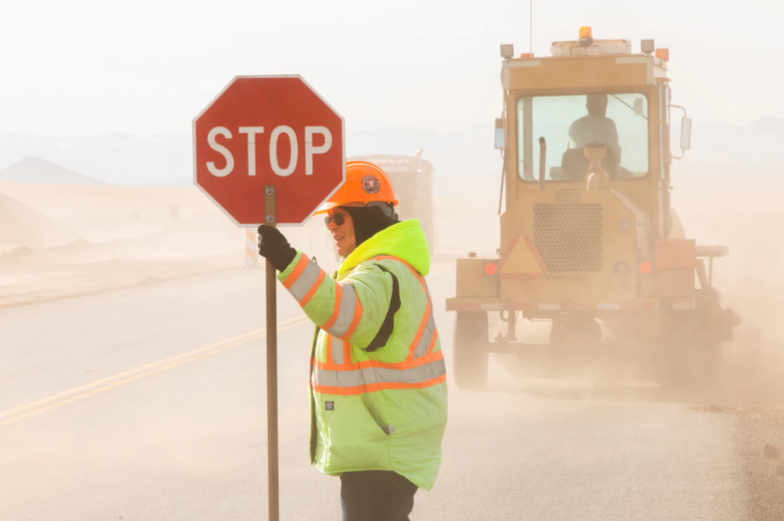
Remember to protect the back of your neck from the sun. Add a brim extender or a neck flap to a hard hat. Or wear a bandana. They’ll protect you from UV and keep you cooler, too. #sunsafety #prevention

Sunglasses. Check.  Hat. Check.  Long sleeves. Check.  Sunscreen. Check.  Forget anything?  Lip balm with SPF 15 or more. Check and done. | 